A Comparison of Software Development Methodologies

Reed Sorensen, Software Technology Support Center

http://www.stsc.hill.af.mil/crosstalk/1995/01/Comparis.asp

Purpose and Scope
This article introduces and compares software development methodologies. This information will help you recognize which methodologies may be best suited for use in various situations. The target audience is all personnel involved in software development for the DoD. No attempt has been made to cover methodologies that are most applicable to smaller projects that can be accomplished by five or fewer software engineers. You may learn about several of these in [10]. Since the intended readers should consider government software standards in their use of methodologies, background on these standards is included.
Terminology
For the purposes of this discussion, Table 1 categorizes software development models and techniques.

Software Development Models(2)
Waterfall
Incremental
Spiral
Software Development Techniques
Prototype
Cleanroom
Object-Oriented
Table 1: Software Development Models and Techniques.(1)

A methodology is composed of one of the software development models used in conjunction with one or more techniques, i.e., methodology = model + technique(s). The techniques of prototyping, cleanroom, and object-oriented are ways to implement the waterfall, incremental, and spiral models. These techniques may be mixed and matched on a single project. Also, portions of a technique may be used without using all aspects of that technique. This means that a project using the spiral model may combine prototyping with object- oriented analysis and design and also use cleanroom testing techniques. Using the METHODOLOGY = MODEL + TECHNIQUE(S) definition, there are more methodologies used than we have time to identify. Therefore, the remainder of the discussion will deal with models and techniques.

Waterfall Model
David Whitgift points out that in the earliest days of software development, code was written and then debugged [17]. There was no formal design or analysis. This code and debug approach rapidly became less than optimal as complex software systems were required. Since the approach to developing complex hardware systems was well understood, it provided a model for developing software.
This model, known as the waterfall, is an approach to development that emphasizes completing a phase of the development before proceeding to the next phase. In conjunction with certain phase completions, a baseline is established that "freezes" the products of the development at that point. If a need is identified to change these products, a formal change process is followed to make the change. The graphic representation of these phases in software development resembles the downward flow of a waterfall.
Each box in Figure 1 represents a phase. Output from each phase includes documentation. The phases below the detailed design phase include software as part of their output. Transition from phase to phase is accomplished by holding a formal review that is attended by the contractor and appropriate government agencies. These reviews provide the government insight into the contractor's progress. At critical points on the waterfall model, baselines are established, the last of which is the product baseline. This final baseline is accompanied by audits. These audits and reviews are defined in MIL-STD-973, and DOD-STD-1521B (see Table 6).
But there are differences between hardware and software that the waterfall model does not address. Unlike hardware, software requires no fabrication. "Once the drawings and models (programs) are complete, the final product exists."[2, p. 30]. Bruce Blum uses the analogies of house building and sculpting to make the point that hardware projects begin with a good understanding of the requirements, and that once fabrication begins, changes are restricted to the cosmetic and minor items. Sculpting can be a less rigid exercise in the sense that moldable clay can be added, removed, or otherwise rearranged.
Blum also points out that hardware production has more history, experience, and criteria upon which to draw than does software development. The criteria for judging success in house building is largely objective, while the success of a sculpture is judged subjectively.
"Lacking objective criteria for establishing the soundness of many or our software designs, we must recognize that our judgement is essentially an aesthetic decision."
"The ... problem with the waterfall model ... is the fact that the flow is optimized for hardware, thereby neglecting the essential characteristics of software."[2, p. 30]
Many software development methodologies have evolved from attempts to optimize the waterfall model for software. For example, software prototyping helps provide the complete understanding of the requirements that is typical of hardware production--which understanding is critical to the waterfall model. Two other examples are the incremental and spiral models (see Figures 2 and 3), which allow the phases identified in Figure 1 to be revisited repeatedly prior to declaring a product to be final. Such revisiting is very costly in hardware development and is to be used sparingly according to the waterfall model.
Having laid some groundwork for the reader, the comparison of models and techniques follows. The comparison of waterfall, incremental, spiral, and prototyping was influenced by [10], which provides a good perspective for anyone trying to make a decision about which methodology to use.
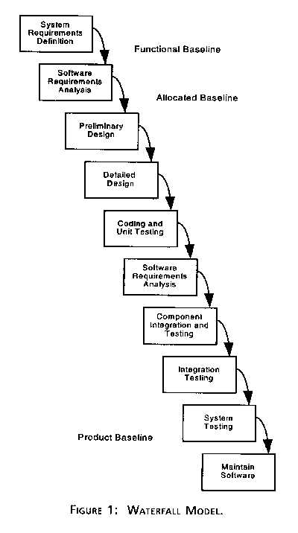
Comparing the Waterfall Model
Description. As illustrated in Figure 1, the waterfall model consists of phases that are completed sequentially before proceeding to the next phase. For comparison to other models, the salient attributes of the waterfall model are that it is
- A formal method.
- A type of top-down development.
- Composed of independent phases to be done sequentially.
- Used in varied ways.
  - Steps are combined.
  - There are different starting and ending points.
Where to Use the Waterfall Model
Because of the weaknesses shown above, the application of the waterfall model should be limited to situations where the requirements and the implementation of those requirements are very well understood.
"For example, if a company has experience in building accounting systems, I/O controllers, or compilers, then building another such product based on the existing designs is best managed with the waterfall model ... ." [2, p. 30](3)
Incremental Model
Description. The incremental model performs the waterfall in overlapping sections (see Figure 2) attempting to compensate for the length of waterfall model projects by producing usable functionality earlier. This may involve a complete upfront set of requirements that are implemented in a series of small projects. As an alternative, a project using the incremental model may start with general objectives. Then some portion of these objectives is defined as requirements and is implemented, followed by the next portion of the objectives until all objectives are implemented. But, use of general objectives rather than complete requirements can be uncomfortable for management. Because some modules will be completed long before others, well-defined interfaces are required. Also, formal reviews and audits are more difficult to implement on increments than on a complete system. Finally, there can be a tendency to push difficult problems to the future to demonstrate early success to management.
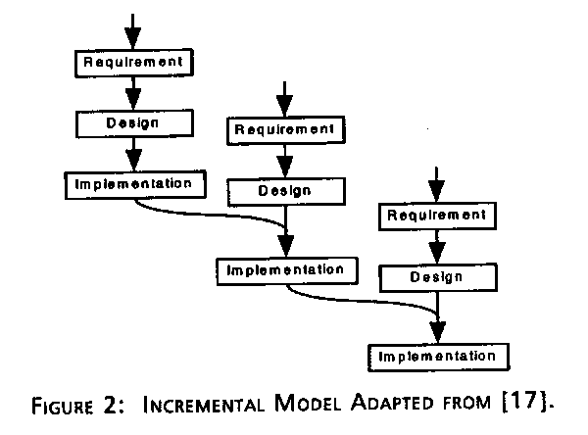
Where to Use the Incremental Model
"If it is too risky to develop the whole system at once, then the incremental development should be considered."[17, p. 13]
Spiral Model
Description. The incremental model can be viewed as a spiral model. The spiral view illustrates one strength of the incremental model: resources can be held constant but the system size grows. The spiral size corresponds to system size, while the distance between the coils of the spiral indicates resources. In Figure 3, the distance between the coils does not change, which indicates that the amount of the resources being used is not changing.
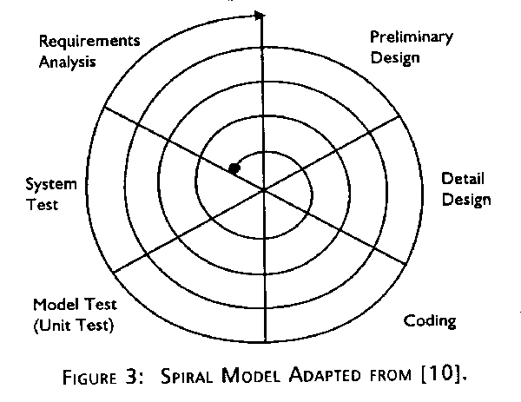
Another spiral model is proposed by Barry Boehm in which prototyping is used to control cost. Prototyping is used upfront with later introduction of the waterfall and increased resources when the risk has been minimized. The increase in resources is seen in the increased distance between the coils of the spiral shown in Figure 4.
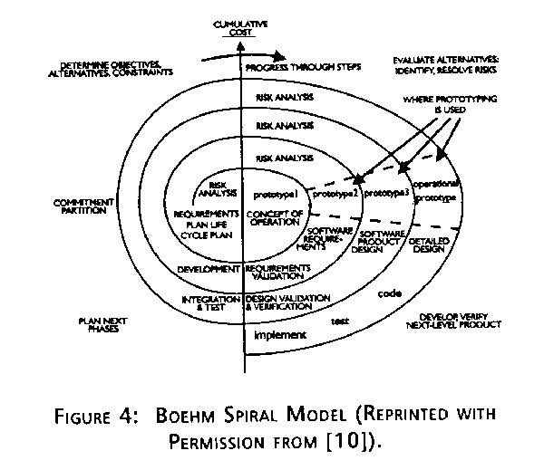
When to Use the Boehm Spiral Model
"Boehm's model has become quite popular among ADE (Aerospace, Defense and Engineering) specialists, and is not so familiar among business developers. ... It is particularly useful in ADE projects, because they are risky in nature. Business projects are more conservative. They tend to use mature technology and to work well-known problems."
"I [DeGrace] believe the spiral model actually is applicable to many business applications, especially those for which success is not guaranteed or the applications require much computation, such as in decision support systems."[10, pp. 116-117]
Table 2 summarizes the strengths and weaknesses of the waterfall, incremental, and Boehm Spiral models.

 | Waterfall | Incremental | Boehm  Spiral
STRENGTHS
Allows for work force specialization | X | X | X
Orderliness appeals to management | X | X | X
Can be reported about | X | X | X
Facilitates allocation of resources | X | X | X
Early functionality |  | X | X
Does not require a complete set of requirements at the onset |  | X(4) | X
Resources can be held constant |  | X
Control costs and risk through prototyping |  |  | X
WEAKNESSES
Requires a complete set of requirements at the onset | X
Enforcement of non-implementation attitude hampers analyst/designer communications | X
Beginning with less defined general objectives may be uncomfortable for management |  | X | X
Requires clean interfaces between modules |  | X
Incompatibility with a formal review and audit procedure |  | X | X
Tendency for difficult problems to be pushed to the future so that the initial promise of the first increment is not met by subsequent products |  | X | X
(4) The incremental model may be used with a complete set of requirements or with less defined general objectives.
Table 2: Strengths and Weaknesses of Models.

Prototyping
Description. Prototyping is the process of building a working replica of a system. The prototype is the equivalent of a mock-up in the hardware world. It may be used with the waterfall in a fashion similar to the Boehm Spiral or it may completely replace it. DeGrace says:
"... you get some sort of requirements list. Sometimes it is quite informal ... . If it is for your customer, the requirements could arrive in some sort of memo."
"Next, you transform the requirements into a working model by changing or operating your (prototype) to include them. With a 4GL [fourth generation language], you transform the requirements into language and macro commands."
"With libraries, you write a "driver," the top-level program, and select and insert calls to the library functions that represent the requirements. Then, you integrate them by writing code to handle input, output, error processing functions, operator messages, and connections between functions ... ."
"... Next, you show the results to the customer or decide whether it is doing what you want. If new requirements emerge, repeat the process."[10]
When to Use Prototyping with the Waterfall
As noted in the description of the Boehm Spiral, prototyping may be used with the waterfall; it can be useful to demonstrate technical feasibility when the technical risk is high. It can also be used to better understand and extract user requirements. In either case, the goal is to limit cost by understanding the problem before committing more resources.
When to Use Prototyping with Objects
Object-oriented development focuses on real-world objects, and will be discussed later.
Coad and Yourdon say that prototyping should always be used with the analysis and design portions of OO.
"OOD (Object-Oriented Design) prototyping tools may be at odds with your organization's "systems development cycle," in which case the best you can do is use the prototyping tools to carry out the antiquated development cycle activities a little bit faster and more easily."
"But gradually, prototyping tools are changing the way people build systems. For many, prototyping is the natural way to work. Nobody today would suggest that programs should be developed by keypunching cards and overnight batch compilation; interactive source program development--whether from a dumb terminal or a smart workstation--is now the norm, the dynamic way to compose programs. Prototyping tools simply take this concept a step further." [9, p. 12]

Strengths of Prototyping
- Early functionality.
- Provides a process to perfect the requirements definition.
- Provides risk control.
- Documentation focuses on the end product not the evolution of the product.
- Provides a formal specification embodied in an operating replica.
Weaknesses of Prototyping
- Less applicable to existing systems than to new, original development.
- Bad reputation among conservatives as a "quick and dirty" method.
- Suffers from bad documentation [16].
- Sometimes produces a system with poor performance.
- Tendency for difficult problems to be pushed to the future so that the initial promise of the prototype is not met by subsequent products [16].
Table 3: Strengths and Weaknesses of Prototyping.

Cleanroom
Description. The cleanroom technique attempts to keep contaminants (software bugs) out of the product. The idea is to control cost by detecting bugs as early as possible, when they are less costly to remove. Rather than using natural languages like English, more formal notations are used to produce specifications on which all software design and requirements validation is based. Off-line review techniques are used to develop understanding of the software before it is executed. Software is intended to execute properly the first time. Programmers are not allowed to perform trial- and-error executions, though automation checks syntax, data flow, and variable types. Testing uses statistical examination to focus on the detection of the errors most likely to cause operational failures.
Cleanroom has been used by several groups that have provided some data for judging the method. Mike Dyer describes a COBOL project that produced 52,000 lines of code with 179 errors, which is 15 to 20 times better than industry norms [12].
The general conclusion is that the resulting programs are more reliable than programs developed with the traditional lifecycle model, that the time required to produce a verified program is less than or the same as the time necessary to design, code, and debug a program, that the method of functional verification scales up to large programs, and that statistical quality control is superior to the time-honored technique of finding and removing bugs [2, p. 419].
When to Use Cleanroom
Cleanroom can be used with waterfall, incremental, or spiral models to produce software of arbitrary size and complexity. Cleanroom has been successfully demonstrated with excellent results but widespread acceptance has not materialized due to its radical nonintuitive approach. Cleanroom provides higher quality software rather than direct productivity increases.
An organization beginning to use cleanroom need only have in place systematic design methods, formal inspection procedures, documented requirements in a natural language, developer-performed unit testing, configuration management of software after its release to the independent test organization, and ad hoc functional testing. The baseline process in Figure 5 represents such an organization. Cleanroom is not an all-or-nothing approach. Figure 5 shows which cleanroom components are most appropriately implemented from the organization's baseline process.

Strengths of Cleanroom
- Production of reliable software.
- Cleanroom may be gradually introduced to an organization.
Weaknesses of Cleanroom
- Needs a complete set of requirements.
- Disciplined style may stifle creativity.
Table 4: Strengths and Weaknesses of Cleanroom.

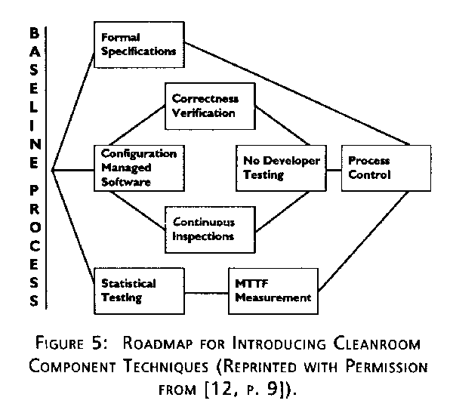
Object-Oriented
Description. The object-oriented approach to software development focuses on real-world objects. It is based on the premise that there exists a fundamental human limitation to manage more than seven different objects or concepts at one time. Grady Booch [5] suggests that the principles of software engineering can help us decompose systems so that we never simultaneously deal with more than seven entities. OO popularity is increasing in concert with the increasing complexity of software systems. OO includes object-oriented analysis (OOA), design (OOD), and programming (OOP).
Where to Use OO
Use OO in projects where
- The system is data-oriented and functional complexity is of lesser concern [8, p. 6].
- Good OO implementation technology is available, and the organization provides adequate tools for its practitioners to effectively use object- oriented techniques.
- The organization is sophisticated enough to successfully change its development methods.
- The systems and applications being developed by the organization are the kind that will most effectively use the OO paradigm [8, p. 188]. Note that OOA is not very useful for systems with very limited responsibilities [8, p. 32].
Graphical user interfaces have been developed successfully using OOA.
Background on Department of Defense Software Standards. Because DoD personnel are to comply with government software standards in their use of methodologies, background on those standards is pertinent to this discussion of methodologies.
History. Military standards covering hardware existed long before software began to play such a large role in the Department of Defense. Naturally enough, the first standards encompassing software development were not specific to software. For software development efforts, these standards had some holes. For example, MIL-STD-490 (a hardware standard that was sometimes applied to software development) describes a system specification, design specification, and a product specification but says nothing about test plans, test procedures, or test results.
The first software development standard, DOD-STD-2167, was released in June 1985 (see Table 6) despite the recognition that it was less than perfect. DOD-STD-2167A followed closely behind in February 1988 and was intended to be independent of any specific software development methodology. The Foreword from DOD-STD-2167A states: "This standard is not intended to specify or discourage the use of any particular software development method. The contractor is responsible for selecting software development methods (for example, rapid prototyping) that best support the achievement of contract requirements." Despite this intent, the standard was interpreted by many to contain an implied preference for the waterfall model (see Figure 1). Waterfall was the state of the practice at the time.

Strengths of Object-Oriented: [15]
- Owners of a problem can participate in deriving the solution.
- Lower maintenance costs because the object-oriented analysis encourages a complete solution.
- The model expresses the user's view of reality.
Weaknesses of Object-Oriented
- Can be difficult for those with a structured analysis background.
- Can be difficult to reconcile with DoD-STD-2167A [11].
Table 5: Strengths and Weaknesses of Object-oriented.

Two Classes of Software
DOD-STD-2167A Defense System Software Development (or 2167A for short) is approved for use by all departments and agencies of the Department of Defense that develop software. While 2167A is often associated most closely with the class of software referred to as "embedded" software systems, it is also applicable to the development of another class of software--the automated information systems (AIS) sometimes referred to as management information systems. DOD-STD-7935A Department of Defense Automated Information Systems Documentation Standards defines the documentation that accompanies development of AIS specifically. DOD-STD-2167A is broader than 7935A in scope because it describes the processes(4) and activities of software development as well as providing direction about documenting the development.
Embedded software is sometimes referred to as "operational" software or as "mission-critical computer resources" that provides direct system functions. In contrast, AIS software may be referred to as "support" software that provides support functions like maintaining data about a system. Embedded software runs on specialized system hardware, while automated information systems (AIS) software runs on a commercial-of-the-shelf PC, workstation, or mainframe computer. The differences between embedded and AIS software was a factor in the use of two DoD software standards--2167A and 7935A.
Despite these differences, there are reasons to move to a single standard called MIL-STD-498 (see Table 6). As software's role in providing functionality in weapon systems expands, more program offices are using both embedded and AIS in their systems. Also, the streamlining of the acquisition process by DoD management has come with a blurring of the distinction between embedded and AIS [13]. Such is the case when AIS software is developed following DOD-STD-2167A while specifying that the software documentation be as described by 7935A. A goal of MIL-STD-498 is to merge DOD-STD-2167A and DOD- STD-7935A into a single document; a process referred to as harmonization. The Harmonization Working Group has gone to some lengths to identify the needed portions of both standards by developing a detailed, paragraph-by-paragraph mapping of the documents identified by both 2167A and 7935A.

Who Cares about DOD-MIL-SPECS?
- The program manager (PM) who manages a system acquisition effort that includes software.
- The project office that assists the PM.
- The contractor who develops the software (contractor could be a government agency).
- The agency that will use the system.
- The agency that will maintain the system.
- Organizations that interface with the above entities and need to be conversant on software acquisition and development topics.
DOD-STD-2167
- DOD-STD-2167 released in June 1985.
- Attempted to establish a standard for development of software for embedded systems. (Not a documentation standard)
- Specifically written for software development.
- Complemented MIL-STD 483 and 490, which are not specific to software development.
- Cumbersome and never caught on.
MIL-STD-973
- Supersedes Appendices G, H, and I of DOD-STD-1521B.
- Describes the audit portions of audits used by the government to oversee the software development.
- Consolidates the configuration management requirements for defense material items.
- Can be tailored.
MIL-STD-498
- Intended to address some shortcomings of DOD-STD-2167A.
- Review draft circulated in December 1992.
- Several thousand comments were received.
- Will supersede DOD-STD-2167A and DOD-STD-7935A as an interim standard until a commercial standard is adopted.
- Can be tailored.
DOD-STD-7935A
- DOD-STD-7935A released in October 1988.
- Applies to automated information systems or application software.
- 7935A is a documentation standard rather than a software development standard.
- Contains guidelines for the development and revision of the documentation.
- Can be tailored.
DOD-STD-2168
- DOD-STD-2168 released in April 1988.
- Covers all aspects of the quality of the software development process including the software and documentation.
- Can be tailored.
MIL-STD-SDD
- Draft standard that led to MIL-STD-498.
- SDD designation derived from software development and documentation.
- Not to be confused with the DOD-STD-2167A product named Software Design Document.
DOD-STD-2167A
- DOD-STD-2167A superseded 2167 in February 1988.
- Established a standard for development of software for embedded systems but may also be applied to automated information systems (AIS). (Not a documentation standard)
- Specifically written for software development.
- Complemented MIL-STD 483 and 490, which address systems including hardware.
- Not intended to specify or discourage the use of any particular software development method.
- References reviews in DOD-STD-1521B and audits in MIL-STD-973.
- Can be tailored.
Table 6: Software Standards at a Glance.

A recent memo from Secretary of Defense William J. Perry calls for greater use of commercial standards such as ISO 9000 (see CrossTalk, March 1994). MIL- STD-498 was approved in November 1994 as an interim standard until a commercial standard is adopted.
Summary
This discussion includes three models and three techniques. There are other models and techniques that were not included. The waterfall, incremental, spiral models, prototyping, Cleanroom, and object-oriented techniques are believed to be those most pertinent to the Department of Defense. An understanding of these models and techniques provides a foundation for understanding others as you encounter them.
Reed Sorensen
Software Technology Support Center
Ogden ALC/TISE
7278 Fourth Street
Hill AFB, UT 84056-5205
Voice: 775-2051 DSN 924-2051
Fax: 801-777-8069 DSN 458-8069
Internet: sorenser@software.hill.af.mil
About the Author
As a member of the Software Technology Support Center (STSC), Reed Sorensen currently assists DoD project managers in applying DoD-STD-2167A and MIL-STD-498. He has worked 15 years for TRW in software development and documentation. Prior to joining the STSC he provided systems engineering and technical assistance to the Peacekeeper missile manager.
References
- Blake, Jeffery, "Software through Pictures vs. Paradigm Plus," Advanced Systems Magazine, June 1994, p. 84.
- Blum, Bruce I., Software Engineering: A Holistic View, 1992.
- Boehm, Barry, "A Spiral Model of Software Development and Enhancement," from Proceedings of an International Workshop on the Software Process and Software Environments, 1985.
- Boehm, B.W., "A Spiral Model of Software Development and Enhancement," Computer, 1988.
- Booch, Grady, Software Engineering with Ada, 1994, p. 25.
- Cobb, Richard, Ara Kouchakdjian, and Harlan D. Mills, The Cleanroom Engineering Software Development Process, Software Technology for Adaptable, Reliable Systems (STARS) Program, February 1991.
- Paulk, Mark C., et al., Capability Maturity Model for Software, Version 1.1, Software Engineering Institute, February 1993 p. L3-18.
- Coad, Peter, and Edward Yourdon, Object-Oriented Analysis, 1991.
- Coad, Peter, and Edward Yourdan, Object-Oriented Design, 1991.
- DeGrace, Peter, and Stahl, Leslie Hulet, Wicked Problems, Righteous Solutions: A Catalogue of Modern Software Engineering Paradigms, 1990, pp. 116, 117, 127. Reprinted with permission of Prentice Hall, Englewood Cliffs, New Jersey.
- Atkinson, Shane, Documentation Technology Report, Software Technology Support Center, April 1994.
- Dyer, Mike, The Cleanroom Approach to Quality Software Development, 1993.
- Summary of Changes to DoD-STD-2167A and DoD-STD-7935A resulting in MIL-STD-SDD, Executive Summary, p. 1, December 1992.
- Guidelines for Successful Acquisition and Management of Software Intensive Systems: Weapons Systems, Command and Control Systems, Management Information Systems, September 1994.
- Morris, Randy, and Boyd Tidwell, "Object-Oriented Ada Using State Controlled Implementation," CrossTalk, June 1994, p. 17.
- Software Management Guide, Vol. I, Software Technology Support Center, October 1993, p. 23.
- Whitgift, David, Methods and Tools for Software Configuration Management, 1991.
(Editor's Note: MIL-STD-498 was approved Nov. 8, 1994 for use as an interim Department of Defense standard. To comply with Defense Secretary William J. Perry's memorandum on military standards (CrossTalk, September 1994, p. 2) a waiver is needed to cite MIL-STD-498 as a requirement in a request for proposal (RFP). An alternate approach that does not require a waiver is to cite MIL- STD-498 as guidance in the RFP, then require a software development plan (SDP) based on the guidance and put the SDP of the winning bidder on contract. We will discuss this issue more in a future CrossTalk.)
(1) These models are called "software lifecycles" in [7].
(2) Evolutionary has not been included since its meaning varies in the literature to a greater degree than do the other terms listed here.
(3) "The waterfall method is not recommended for major software-intensive Air Force acquisition programs."[14]
(5) The 2176A description of process is not directly correlated with the Software Engineering Institute Capability Maturity Model (SEI CMM). You can use 2167A at any level of th CMM. Both 2167A and the CMM indicate that certain types of information about the software development process need to be recorded. There is significant overlap in the types of information identified by 2167A and the CMM.

